

Downtown Inman Pavilion Rental Application

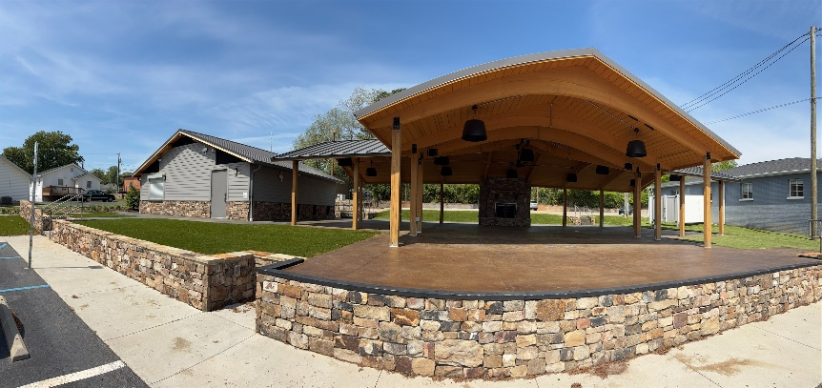
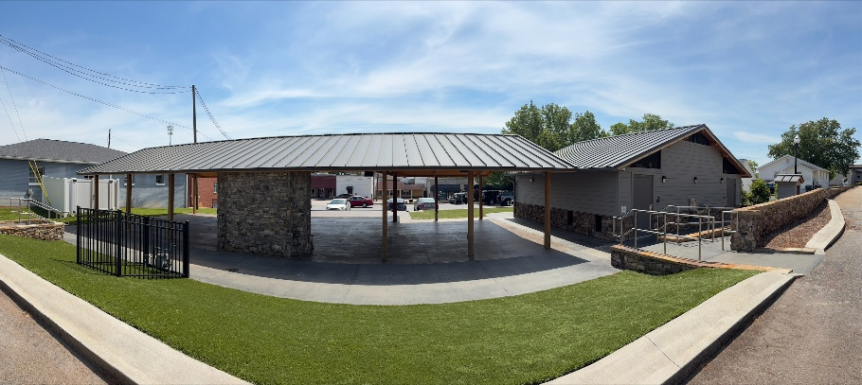
Thank you for your interest in renting the Downtown Inman Pavilion located at 26 Mill Street, Inman, SC 29349. We’re excited to offer this space for small gatherings, celebrations, and community use. Please complete the information below so we can help make your event a success.

Note: This application must be completed and submitted to the Main Street Director not less than thirty (30) days prior to the start of the event. Any misrepresentation or deviation from the final agreed upon rental and/or method of operation described herein may result in the immediate revocation of the rental. ALL questions must be fully answered. If a question does not apply, please write “Does not apply” in space. NO question should be left blank. Please type or print the information clearly.
The information requested by this form will be used to determine your eligibility for the Pavilion rental. Completed forms must be released upon the request of any citizen as provided by the Freedom of Information Act. Additional information may be necessary for approval of certain events. Completion of this form is voluntary; however, failure to do so will prevent processing of your application. Incomplete applications will not be processed.
The application process begins when you submit a completed Downtown Inman Pavilion Rental Application to the City of Inman. Keep in mind that receipt of your application should in no way be construed as final approval or confirmation of your request. A representative from the City of Inman will contact you upon receiving the application and thereafter serve as your primary point of contact for the processing of your application. Copies of the application may be forwarded and reviewed by ALL affected City departments.

Mill Street Parking Lot Request (if applicable)
Will your event require closure of the Mill Street Parking Lot?
Yes No
Note: Closure of the Mill Street Parking Lot is not permitted under this standard pavilion rental. Events requiring use of this space must apply for and receive approval through the City of Inman Special Event Permit process.

Event Setup
Will your event include any of the following?
Tables Chairs Decorations Amplified Sound
If yes, describe: ______________________________________________________________________

Food & Beverage
Will food be present?
Yes No
Note: Alcohol is not allowed at the Downtown Inman Pavilion under this application. Events wishing to serve alcohol must apply for and receive approval through the City of Inman Special Event Application process.
If yes, select type:
Personal Use Only Catered Other: __________________________
Note: Food trucks and mobile food vendors are not permitted under pavilion rental agreements. Events wishing to include food trucks must apply for and receive approval through the City of Inman Special Event Application process.

Contact Information
Applicant Name: ____________________________________________________________________
Applicant Phone Number: ____________________________________________________________
Person in Charge of Event: ____________________________________________________________
Organization Represented (if applicable): ______________________________________________
Address: ____________________________________________________________________________
Event Details
Name of Pavilion Event: ______________________________________________________________
Date(s) of Pavilion Rental: ____________________________________________________________
Rental Start Time: _____________ Rental End Time: _____________
Please include time needed to set up and clean up.
There will be no rentals during the hours of 10:00 pm. and 7:00 am.
Description of Event: _________________________________________________________________
Estimated Number of Attendees: ____________________________________
Rental Fees
Pavilion Rental:
- City Residents: $75 per hour (2-hour minimum rental; minimum charge of $150)
- Non-City Residents: $100 per hour (2-hour minimum rental; minimum charge of $200)
2-hour minimum rental required
Proof of residency: Applicants requesting the City of Inman rate must present a valid government-issued photo ID showing a City of Inman address. If proof of residency cannot be verified, the non-city resident rate will apply.

Total Hours Requested: _____________ Estimated Rental Fee: __________________

Add-On Options
- Concession Stand Access (+ $50/hour)
- Electrical Access
- Water Access Needed
If electrical is requested, describe use:
____________________________________________________________________________________

Fees & Deposit
A $50 refundable deposit is required to secure your reservation. This deposit will be returned after the event provided the space is left clean undamaged, and all rental conditions have been met.

Acknowledgement & Agreement
I understand this is a facility rental only and does not constitute a Special Event Permit.
I agree to leave the Downtown Inman Pavilion clean and in good condition and accept responsibility for any damages or excessive cleanup associated with my event.
I understand additional permits may be required depending on the nature and scope of my event.
I understand that alcohol is not permitted under this pavilion rental. Any event wishing to serve alcohol must apply for and receive approval through the City of Inman Special Event Permit process.
I understand that food trucks and mobile food vendors are not permitted under this pavilion rental and require a separate Special Event Permit and City approval.
I understand that requests involving parking lot closures are not permitted under this pavilion rental and require a separate Special Event Permit and City approval.
I understand that City-sponsored events take priority in scheduling.
I agree to the above terms and conditions

Signature: _____________________________________________ Date: _____________________

Office Use Only
Residency Verification
- City Resident Verified
- Non-City Resident
- ID Name & Address: ___________________________________________________________
- Staff Initials: _________
Fees Collected
- Pavilion Rental Fee: $__________
- Concession Stand Fee: $________
- Security Deposit: $50 ☐ Paid
- Total Amount Collected: $________
Payment Information
- Payment Method:
☐ Cash ☐ Check ☐ Credit/Debit
- Receipt #:__________
- Date Paid: __________

Reservation Approved By: _________________

